## EUGENE RUSSEL

## 192011387

## 1.UML DIAGRAM FOR LIBRARY MANAGEMENT SYSTEM

## AIM:

To draw UML diagrams for Library management system using Umbrello tool.

## INTRODUCTION:

In the Unified Modeling Language, a use case diagram can summarize the details of your system's users (also known as actors) and their interactions with the system. To build one, you'll use a set of specialized symbols and connectors. An effective use case diagram can help your team discuss and represent:

* + Scenarios in which your system or application interacts with people, organizations, or external systems
  + Goals that it helps those entities (known as actors) achieve
  + The scope of your system Common components include:
  + **Actors** - the users that interact with a system. An actor can be a person, an organization, or an outside system that interacts with your application or system. They must be external objects that produce or consume data.
  + **System** - a specific sequence of actions and interactions between actors and the system. A system may also be referred to as a scenario.
  + **Goals** - the end result of most use cases. A successful diagram should describe the activities and variants used to reach the goal.

## USE CASE DIAGRAM OBJECTS

* + Actor
  + Use case
  + System
  + Package

The objects are further explained below.

**Actor:**

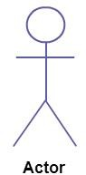

**Use Case:**

Actor in a use case diagram is **any entity that performs a role** in one given system. This could be a person, organization or an external system and usually drawn like skeleton shown below.

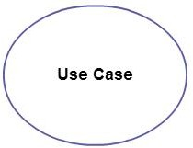A use case **represents a function or an action within the system**. Its drawn as an oval and named with the function.

## System:

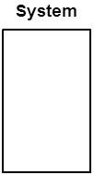

**Package:**

System is used to **define the scope of the use case** and drawn as a rectangle. This an optional element but useful when your visualizing large systems. For example you can create all the use cases and then use the system object to define the scope covered by your project. Or you can even use it to show the different areas covered in different releases.

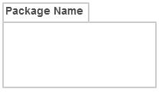Package is another optional element that is extremely useful in complex diagrams. Similar to [**class diagrams**](http://creately.com/diagram-type/class-diagram), packages are **used to group together use cases**. They are drawn like the image shown below.

**USE CASE SCENARIOS**:

**LOGIN:**

To interact with the system, LMS will validate its registration with this system. The actors involved are

* Administrator
* Librarian
* member

**View user details:**

* 1. To see the details of the registered user & the books currently borrowed from the library.
  2. Member can involve.
  3. User must be logged into the system.

## View books:

1. To display the details, when a member, guest or administrator want to see the details on the available books.
2. The Actors involved in step are Administrator, guest and member.

## Reserve Books:

1. User can reserve a book by inputting the relevant details and the librarian can also reserve a book for a member

## Search books:

1.Member or guest can search for a particular book in the book library by book name or category or author name.

## Issue books:

1. This use case can describe the process of issuing a certain book for a member by librarian.
2. Get the member ID and book ID before issue a book.
3. Check the availability.

## Return books:

1. This use case describes the process of return a book.
2. If return book is late member should be paid fine.

## View Members:

To display the details, when a member, guest or administrator wants to see the details of the registered user.

## Add /remove members:

Only administrator is allowed to add or remove a member from library data base .to remove a member, member should request to leave the library.

## USE CASE DIAGRAM:

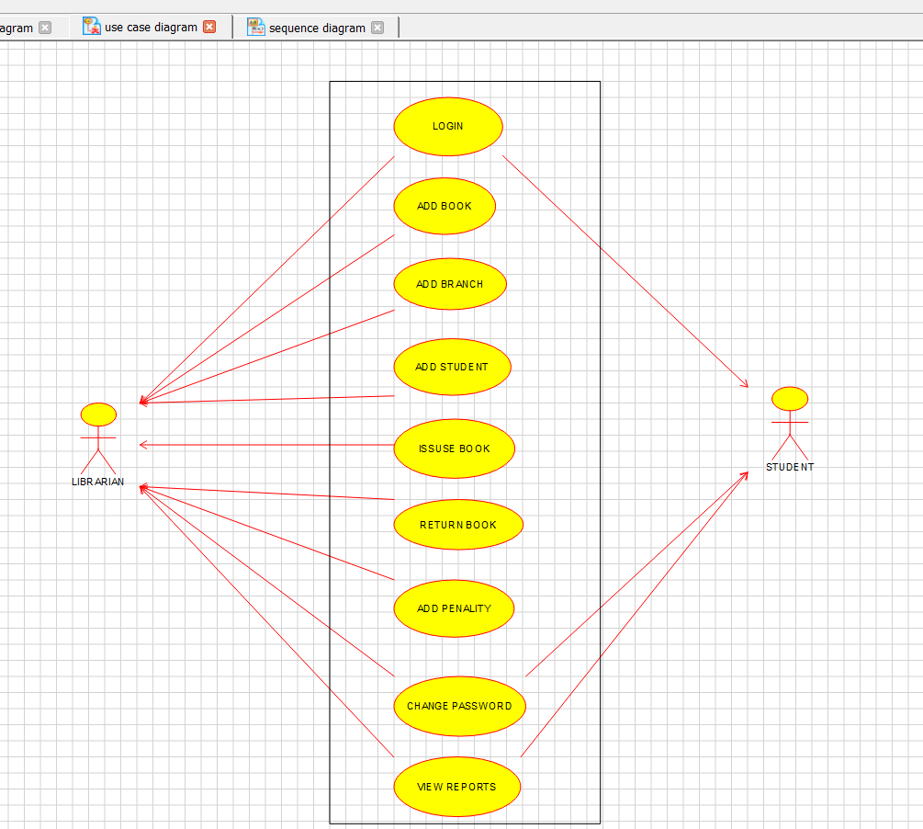

**CLASS DIAGRAM:**

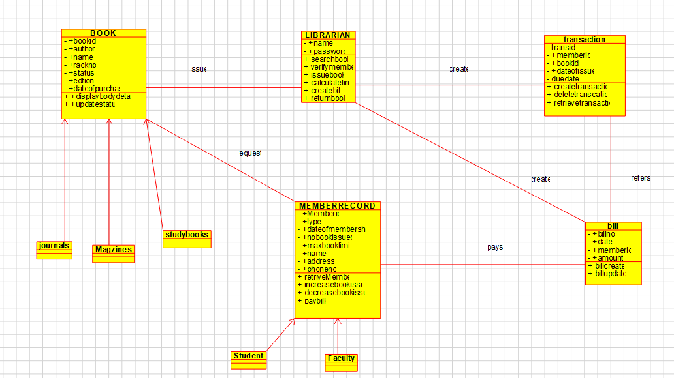

**SEQUENCE DIAGRAM:**

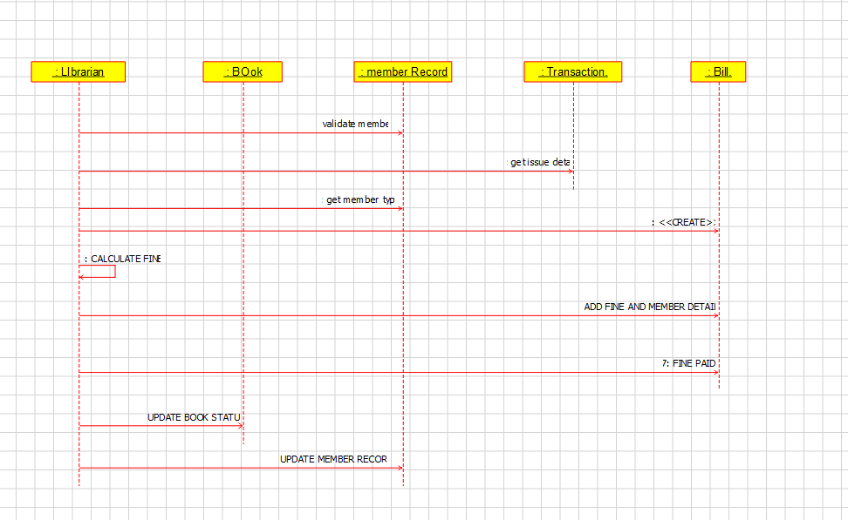

## ACTIVITY DIAGRAM:

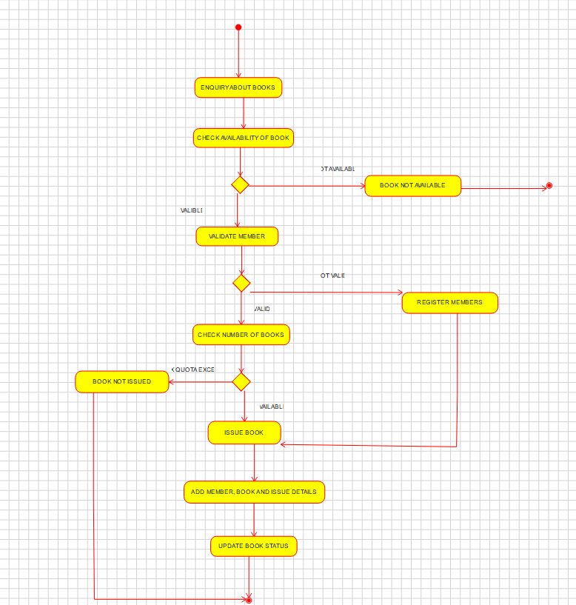

## RESULT:

Thus, the use-case diagram for online voting system is drawn and verified successfully.